Name: Date: unstressed er

The schwa sound (like uh) is normally represented by the letters er at the end of words of more than one syllable, like in the words below.

Remember: Say the word aloud, then say each letter aloud as you write it e.g. 'sister, s ... i ... s ... t ... e ... r'

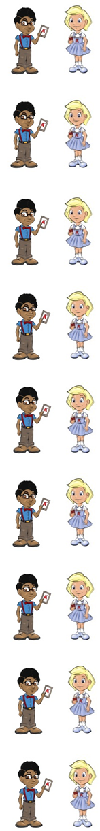
Do you have a sister (sis/ter)?

What time do you eat your dinner (din/ner)?

Will you do it now or later (la/ter)?

You use a hammer (ham/mer) to hit a nail.

You write on paper (pa/per).

Shall we go under or over (o/ver)?

Shall we go under (un/der) or over?

Six is a number (num/ber).

A river (riv/er) takes water to the sea.

Now test yourself without looking at the words and check for yourself if you got them all right. Practice writing any words that you made mistakes on again.

© www.SaveTeachersSundays.com 2013

Name: Date: unstressed er

The schwa sound (like uh) is normally represented by the letters er at the end of words of more than one syllable, like in the words below.

Remember: Say the word aloud, then say each letter aloud as you write it e.g. 'sister, s ... i ... s ... t ... e ... r'

Try to spell each word without looking at it.

Do you have a ?

What time do you eat your ?

Will you do it now or ?

You use a to hit a nail.

You write on .

Shall we go under or ?

Shall we go or over?

Six is a .

A takes water to the sea.

Now check for yourself if you got them all right. Practice writing any words that you made mistakes on again.

© www.SaveTeachersSundays.com 2013

